NEWS RELEASE

**FOR IMMEDIATE RELEASE**

**FPO**

**CONTACT:**

Office Holder| Title

Address

City, State ZIP

Phone |Email

**County/Town/Parish, State is fighting back against property fraud by offering PropertyCheckTM powered by Cott Systems.**

**County/Town/Parish, State –** **Date –** Officeholder Name and Title announced today that they have implemented Cott Systems’ PropertyCheck**TM** in an invigorated effort to combat property and mortgage fraud in **County/Town/Parish**. This 24/7 service allows residents to sign up on the Cott Systems’ RECORDhub**TM** website (https://recordhub.cottsystems.com) to receive notifications when official documents are recorded on their property. Residents can activate alerts based on their name, property address, or parcel number. There is a free service to the citizens of **County/Town/Parish**.

WHAT IS PROPERTY FRAUD? Property fraud can occur if someone forges your identity, transfers your property into their name, and records the document. This fraudulent activity can make it appear as if that person owns your home or property - and you may not have any idea that this happened! It is, unfortunately, becoming more prevalent today as cyber criminals exploit every avenue they can to cause harm and steal from everyday citizens.

Cott System’s PropertyCheck**TM** works seamlessly in the background of the Name of County/Town/Parish records management RECORDhub software, automatically alerting on an enrolled record if a document with matching name or address is recorded. Property owners need to opt-in by creating a RECORDhub**TM** account, create alerts for their name and/or property address (where applicable) and choose the preference of alerts – email or text message. “It’s also a good idea to set up multiple alerts based on first, middle and last name variations and your spouse’s name, to be sure that an alert will be triggered in case a recording happens with some kind of slight variation,” says Paul Fetters, the product Implementation Specialist at Cott Systems.

County/Town/Parish has partnered with Cott Systems to offer this no-cost solution, adding an additional layer of protection to records data and allowing residents to feel safer in their homes. Officeholder Name and Title explains, “optional quote…(ie: proud to offer this and encouraging all residents to sign up.)”

To activate this benefit, residents of County/Town/Parish can simply sign up for **PropertyCheckTM** alerts at: https://recordhub.cottsystems.com

**About the County/Town/Parish Office**

optional description

**ABOUT COTT SYSTEMS**

An innovator in records management for 135 years, Cott Systems empowers local government offices to improve efficiency, provide superior constituent service, and preserve the official records entrusted to their care. Decades of dedication make it possible for Cott Systems to provide all the services a local official needs to preserve and modernize the rich history of their jurisdiction. In addition to industry-leading software solutions, Cott Systems also offers traditional data and imaging services. For more information about Cott Systems, please visit cottsystems.com.

-###-

LOGOS/IMAGES FOR USE:

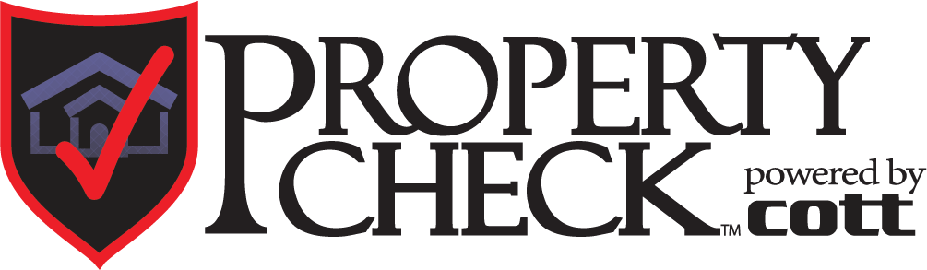



*Credit: Adobe Stock Photo*